- Amar Malkiat Singh
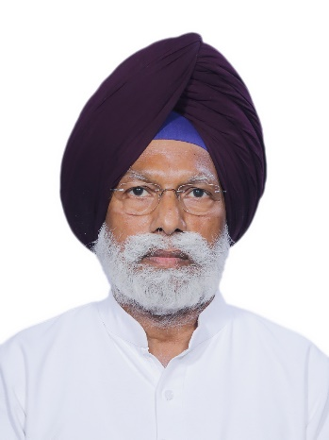
Personal profile:
DOB: 26th May 1953
Educational background: MA Economics, MBBS, Government Medical College, Amristar and Barkatullah University
Positions held: Principle Secretary Government of Madhya Pradesh 1997-2004
Joint Secretary Government of India 2004-2010
Executive Director Food Corporation of India 2010-2012
Chairman and Managing Director Food Corporation of India 2012-2012
Vice President, Punjab Pradesh Congress Committee 2014
Member of Parliament Fatehgarh Sahib 2019

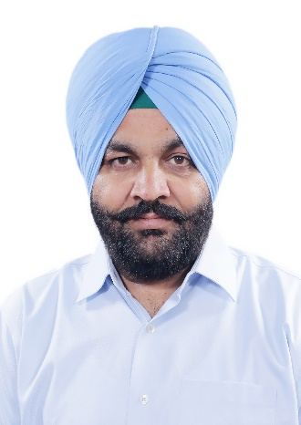
- Gurjeet Singh Aujla
Personal profile:
DOB: 30th October 1972
Educational background: Higher Secondary Educated at P.N.B. Sr. Secondary School, Amritsar, Punjab
Positions held: Won by-poll to the Lok Sabha seat in Amritsar in 2017
Won from the Amritsar Lok Sabha seat in 2019 Indian general elections

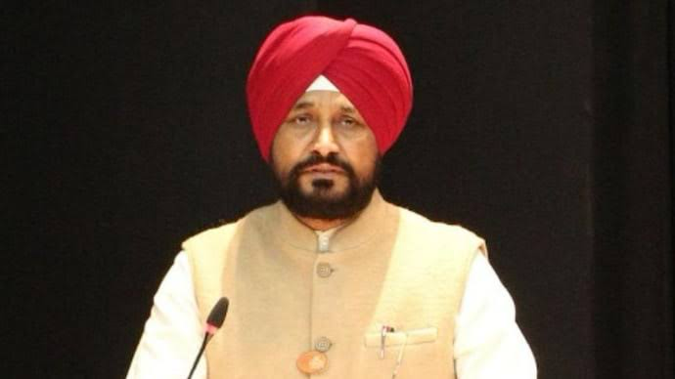
- Charanjit Singh Channi
Personal profile:
DOB: 2nd April 1963
Educational background: Panjab University (B.A., L.L.B., PhD) and Punjab Technical University (MBA)
Positions held: Leader of Opposition Punjab Assembly 11th December 2015- 11th November 2016
Cabinet Minister, Government of Punjab 16th March 2017- 18th September 2021
MLA Chamkaur Sahib 2012-2022
16th Chief Minister of Punjab
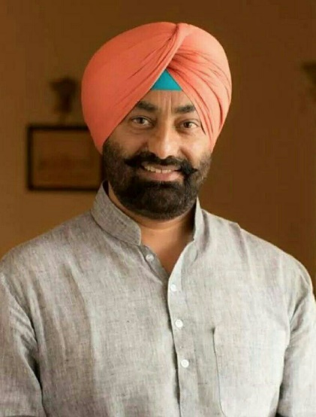
4. Sukhpal Singh Khaira
Personal profile:
DOB: 13th January 1965
Educational background: Bishop Cotton School, Shimla
DAV College, Chandigarh
Positions held: MLA Bholath Constituency 2007, 2017, 2022
Leader of Opposition Punjab Assembly July 2017-July 2018
All India Kisan Congress Chairman July 2022-

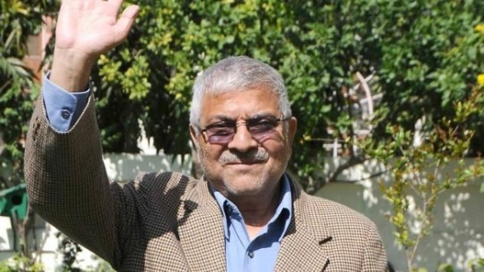
- Dharamvir Gandhi
Personal profile: One of the most senior heart surgeons in the nation, takes part in philanthropic activities and provides free healthcare to the needy and underprivileged. Has been running his NGO for the past 30 years.
DOB: 1st June 1951
Educational background: MD Medicine
Positions held: MP Patiala 2014

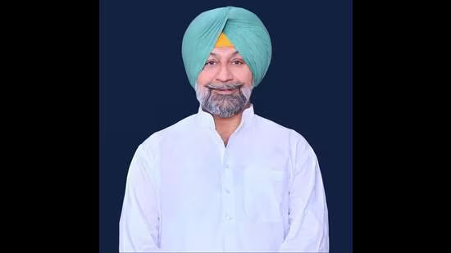
- Jeet Mohinder Singh Sidhu
Personal profile:
DOB:
Educational background:
Positions held: MLA Talwandi Sabo 2002, 2007, 2012, 2014 by-poll

